**Name : Ranudi Gayathmie Kariyapperuma**

**Index : 29897**

**Batch No : 23.1**

**Degree Program Name : Technology Management**

LAB SHEET – 4

Scenario 1 :

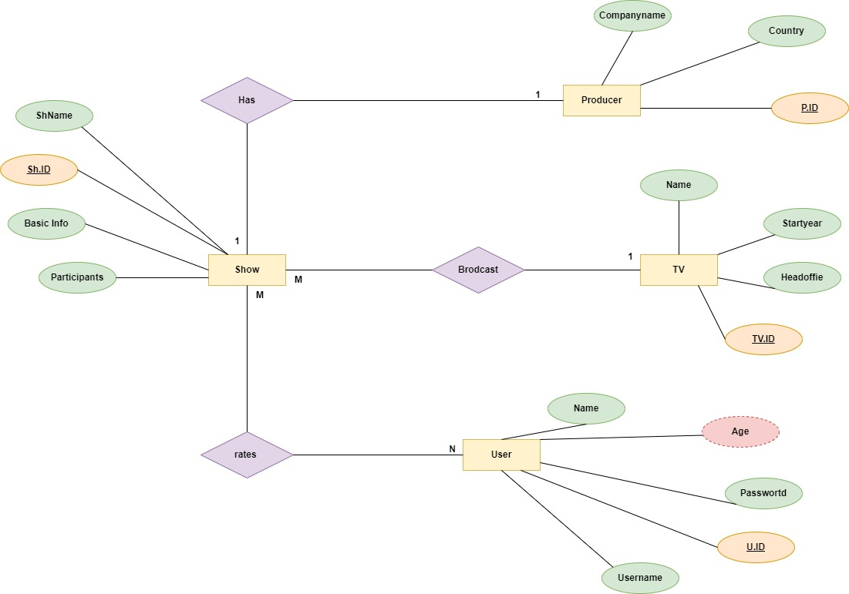

Scenario 2 :

